1.Implementation of CI/CD Pipelines for the Hiring App Using Jenkins Source Code Repository: https://github.com/betawins/hiring-app.git
Objective:
Implement CI/CD pipelines for the Hiring App application using Jenkins. The repository contains the application code for the Hiring App. The following Jenkins pipeline jobs were created and executed successfully:
- Declarative Pipeline Job
- Scripted Pipeline Job
- Multi-Stage Pipeline Job
- Parallel Stage Pipeline Job
The pipelines perform source code checkout, Maven build, SonarQube analysis, and artifact archiving as part of the CI/CD process.
This looks professional and is suitable for submitting as an assignment or lab document.
Step 1: Create a Docker Network
docker network create cicd-network
Verify:
docker network ls

Step 2: Run Jenkins Container
docker run -d \
--name jenkins \
--network cicd-network \
-p 8081:8081 \
-v jenkins_home:/var/jenkins_home \
jenkins/jenkins:lts
Get the Jenkins password:
docker exec jenkins cat /var/jenkins_home/secrets/initialAdminPassword
Open:
http://<EC2-Public-IP>:8081
Install Suggested Plugins.

Step 3: Run SonarQube Container
docker run -d \
--name sonarqube \
--network cicd-network \
-p 9000:9000 \
sonarqube:lts-community
Open:
http://<EC2-Public-IP>:9000
Login:
Username: admin
Password: admin
Generate a token:
Administration → Security → Users → Tokens

Step 4: Run Nexus Container
docker run -d \
--name nexus \
--network cicd-network \
-p 8081:8081 \
sonatype/nexus3
Open:
http://<EC2-Public-IP>:8081
Get the password:
docker exec nexus cat /nexus-data/admin.password
Create two repositories:
- maven-releases
- maven-snapshots
For maven-snapshots:
Version Policy: Snapshot
Deployment Policy: Allow Redeploy

Step 5: Install Required Jenkins Plugins
Go to:
Manage Jenkins → Plugins
Install:
- Git Plugin
- Maven Integration Plugin
- SonarQube Scanner Plugin
- Nexus Artifact Uploader Plugin
- Slack Notification Plugin
- Deploy to Container Plugin
Restart Jenkins.

Step 7: Configure Maven
Manage Jenkins → Tools
Add:
Name: maven
Install Automatically: ✓
Save.

Step 8: Configure SonarQube
Manage Jenkins → System → SonarQube Servers
Add:
Name: SonarQube
Server URL: http://sonarqube:9000
Authentication Token: <SONAR_TOKEN>
Save.

Step 9: Configure Slack
Create an Incoming Webhook in Slack.
Manage Jenkins → System → Slack
Provide:
Workspace URL
Webhook URL
Channel Name
Save.

Step 10: Create Freestyle Job
New Item → Freestyle Project
Name:
hiring-app-cicd
Click OK.

Stage 1: Git Clone
Source Code Management → Git
Repository URL:
https://github.com/betawins/hiring-app.git
Branch:
*/main
Save.

Stage 2: SonarQube Analysis
Build → Execute Shell
mvn sonar:sonar \
-Dsonar.projectKey=hiring-app \
-Dsonar.host.url=http://sonarqube:9000 \
-Dsonar.login=<SONAR_TOKEN>

Stage 3: Maven Compilation
Build → Invoke Top-Level Maven Targets
Goals:
clean package
WAR file generated:
target/hiring.war

Stage 4: Nexus Artifactory Upload
Important
Edit pom.xml:
<version>0.1-SNAPSHOT</version>
Commit and push:
git add .
git commit -m "Changed to snapshot version"
git push origin main
In Jenkins:
Post Build Actions → Nexus Artifact Uploader
Repository:
maven-snapshots
Configuration:
GroupId : in.javahome
ArtifactId : hiring
Version : 0.1-SNAPSHOT
Type : war
File : target/hiring.war
Save.

Stage 5: Slack Notification
Post Build Actions → Slack Notifications
Enable:
- Notify Build Start
- Notify Success
- Notify Failure
Save.

Build Now
Click:
Build Now
Expected Flow:
Git Clone
↓
SonarQube Analysis
↓
Maven Build
↓
Nexus Upload
↓
Slack Notification

Verification URLs
Jenkins:
http://:8081
SonarQube:
http://:9000
Nexus:
http://:8082

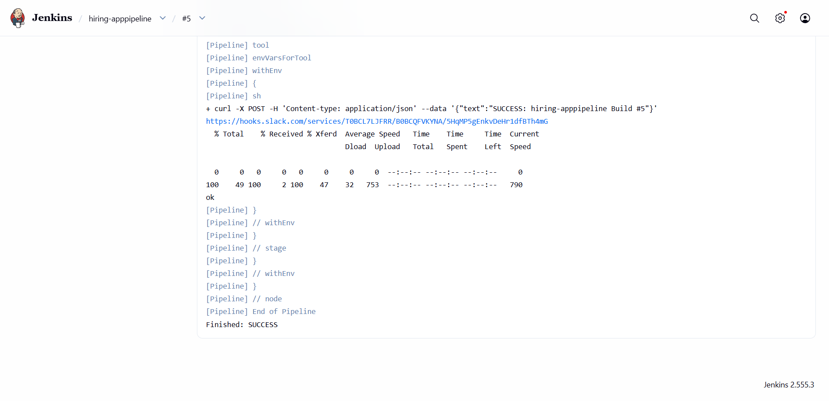
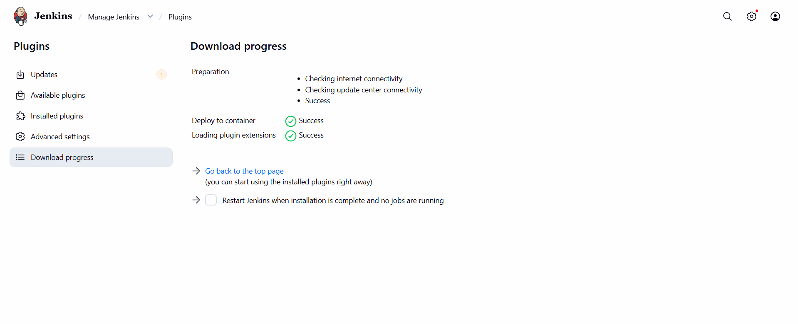
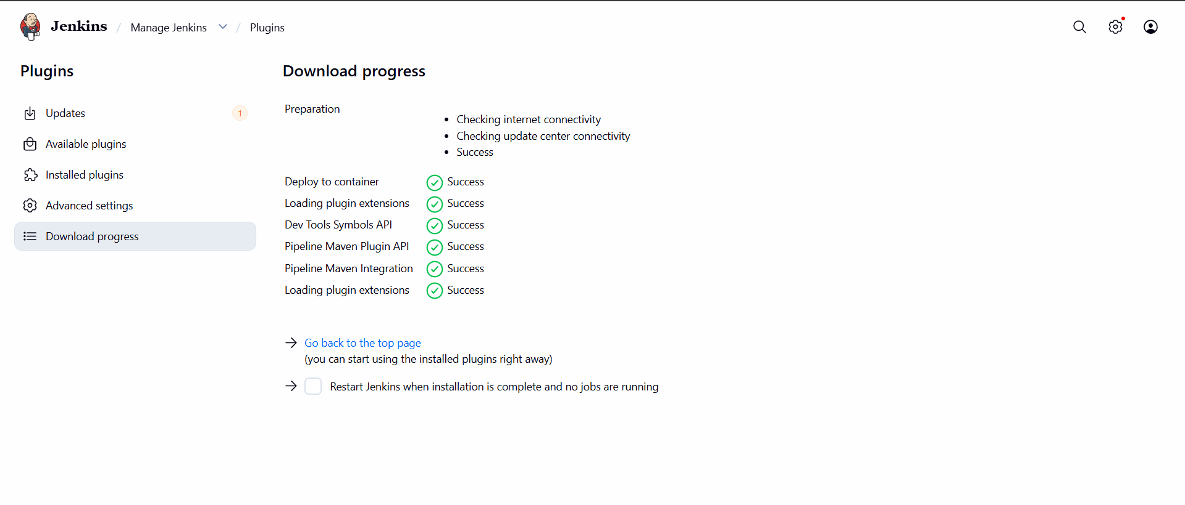
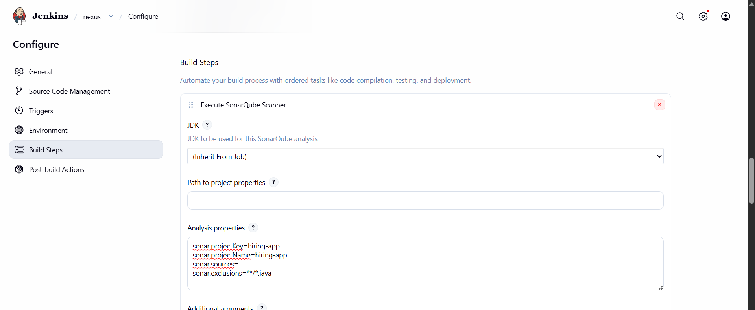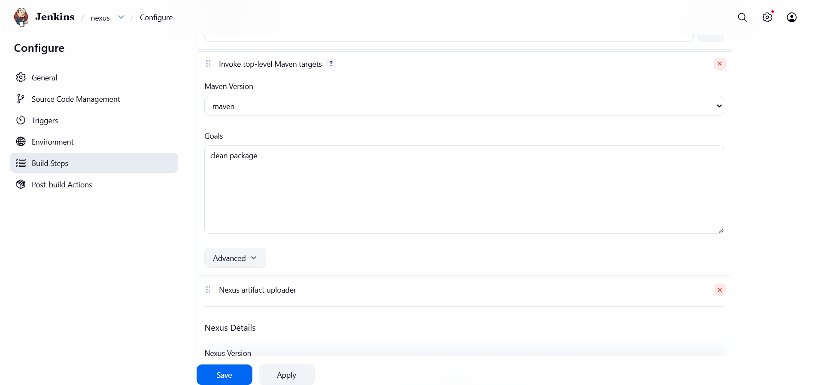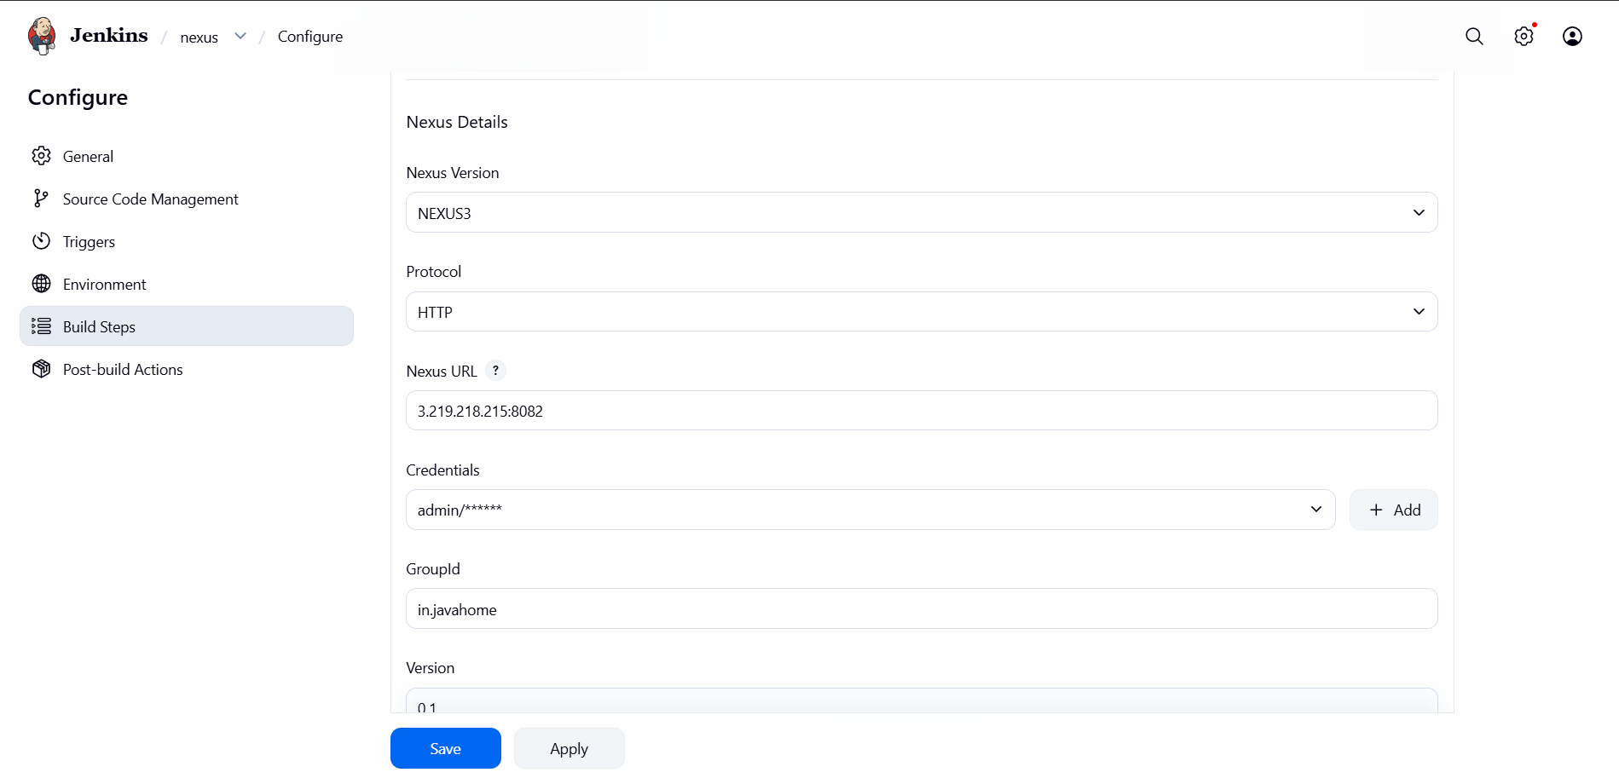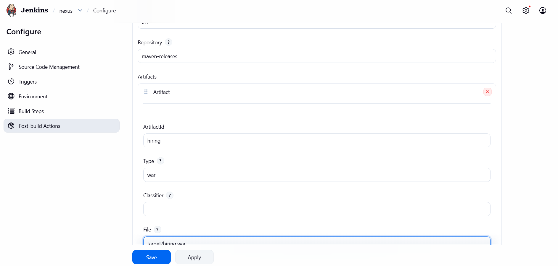
1.Steps to Create a Declarative Pipeline Job in Jenkins
Step 1: Login to Jenkins
- Open Jenkins in your browser.
- Enter your username and password.

Step 2: Create a New Job
- Click New Item on the Jenkins Dashboard.
- Enter the job name:
  - Hiring-App-Declarative
- Select Pipeline.
- Click OK.

Step 3: Configure the Pipeline Job
- In the General section, you can add a description such as:
  - Declarative Pipeline for Hiring App CI/CD.

Step 4: Configure Pipeline Definition
- Scroll down to the Pipeline section.
- Under Definition, select:
  - Pipeline script

Step 5: Save the Job
- Click Save.

Step 6: Build the Job
- Click Build Now from the left menu.

Step 7: Verify the Pipeline Execution
After the build starts:
- Click the Build Number (for example, #1).
- Open Console Output to verify that the pipeline executed successfully.
- Open Stage View to see the pipeline stages.

These steps complete the "Create one Declarative Pipeline Job" requirement of your assignment.
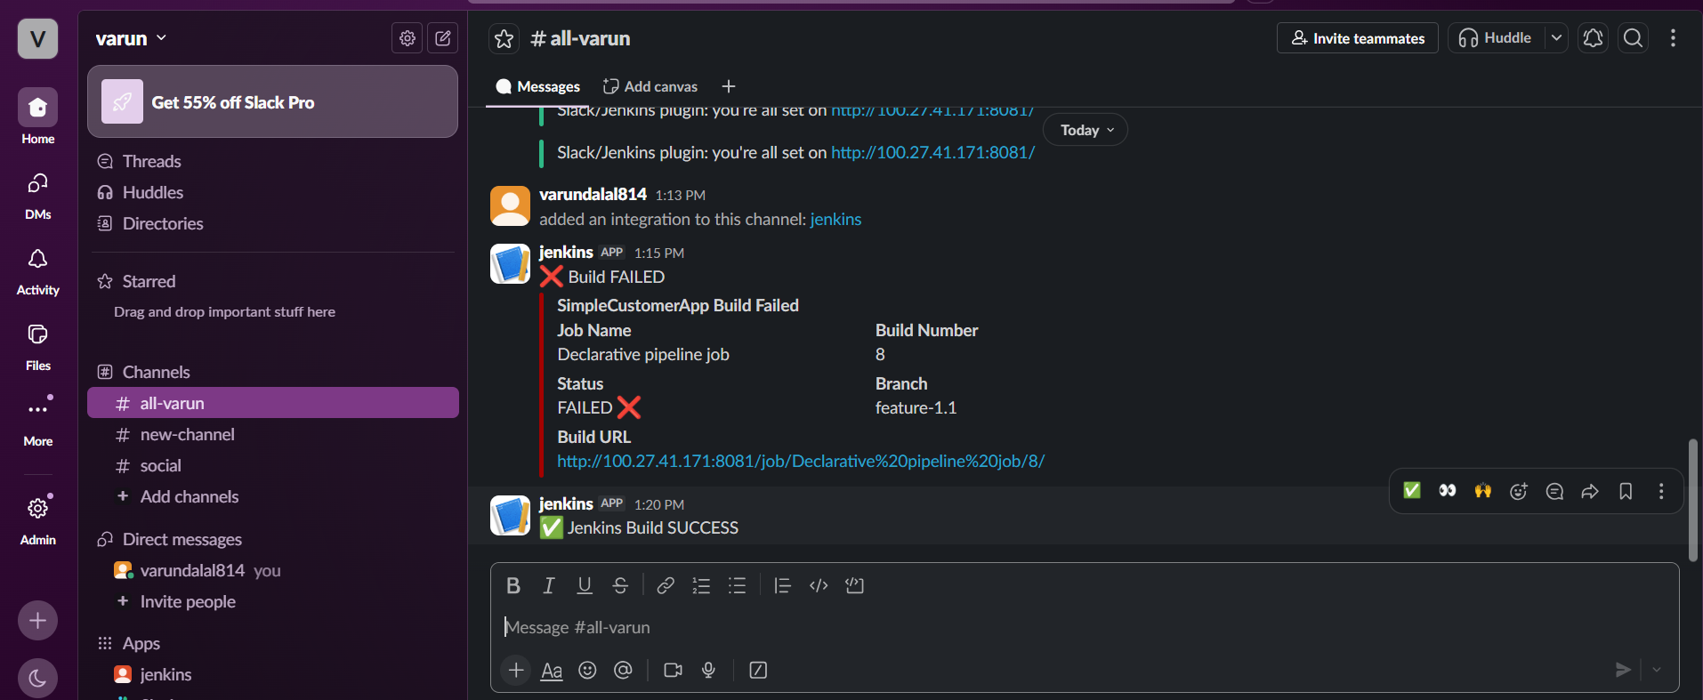
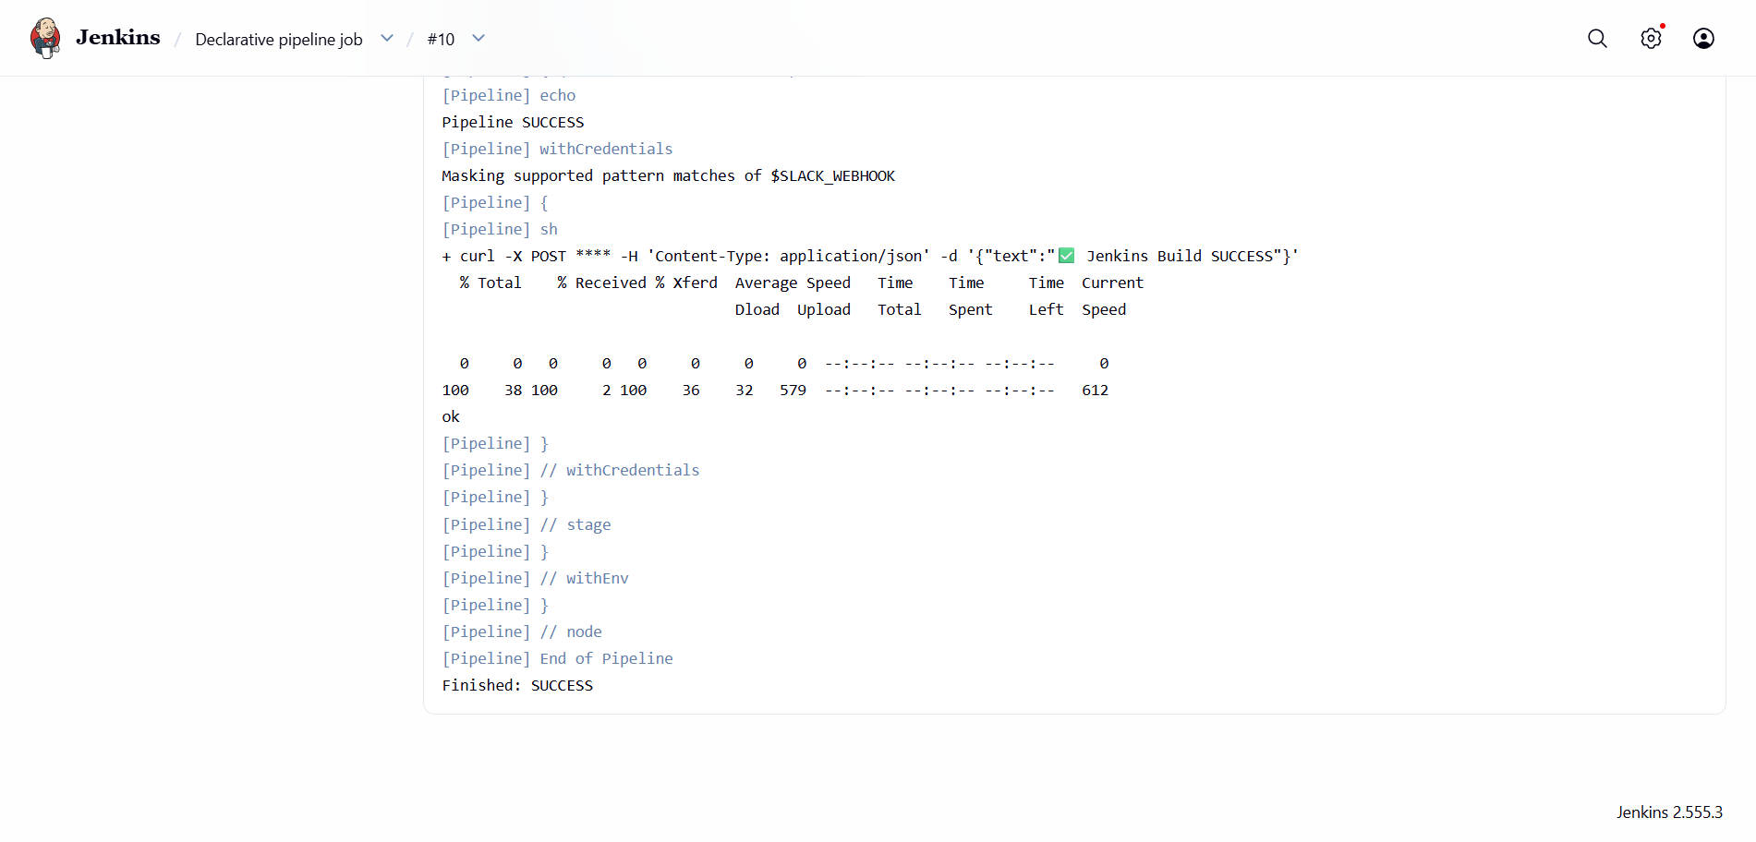

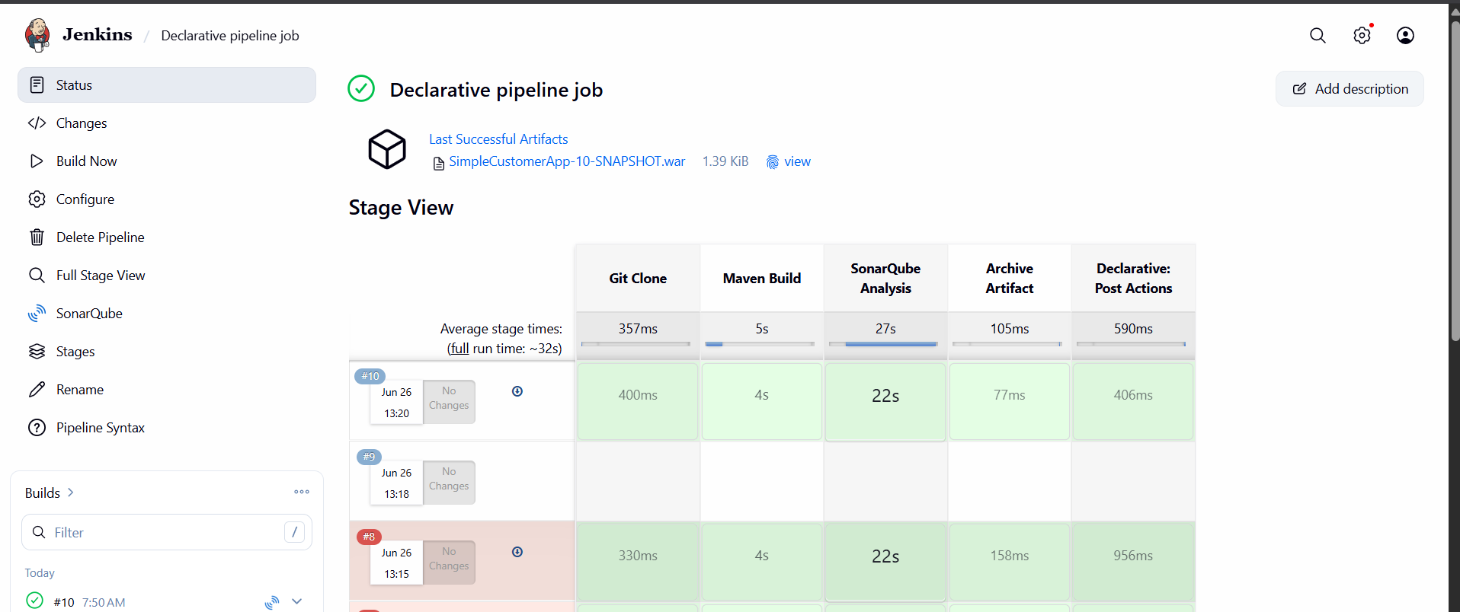

Steps to Create a Scripted Pipeline Job in Jenkins
Step 1: Login to Jenkins
- Open Jenkins in your browser.
- Enter your username and password.

Step 2: Create a New Job
- Click New Item.
- Enter the job name:
  - Hiring-App-Scripted
- Select Pipeline.
- Click OK.

Step 3: Configure the Job
- In the General section, add a description:
  - Scripted Pipeline for Hiring App CI/CD.

Step 4: Configure the Pipeline
- Scroll down to the Pipeline section.
- Under Definition, select:
  - Pipeline script.

Step 5: Define the Pipeline Stages
The Scripted Pipeline should execute the following stages:
- Git Clone
  - Clone the source code from the GitHub repository.
- Maven Build
  - Build the application using Maven.
- SonarQube Analysis
  - Analyze the code quality using SonarQube.
- Archive Artifact
  - Archive the generated WAR file.

Step 6: Save the Job
- Click Save.

Step 7: Build the Job
- Click Build Now.

Step 8: Verify the Build
- Open the latest build from Build History.
- Check the Console Output to ensure all stages executed successfully.
- Verify that all stages completed without errors.

Expected Stage Flow
Git Clone
↓
Maven Build
↓
SonarQube Analysis
↓
Archive Artifact
This completes the Create one Scripted Pipeline Job requirement of your assignment.

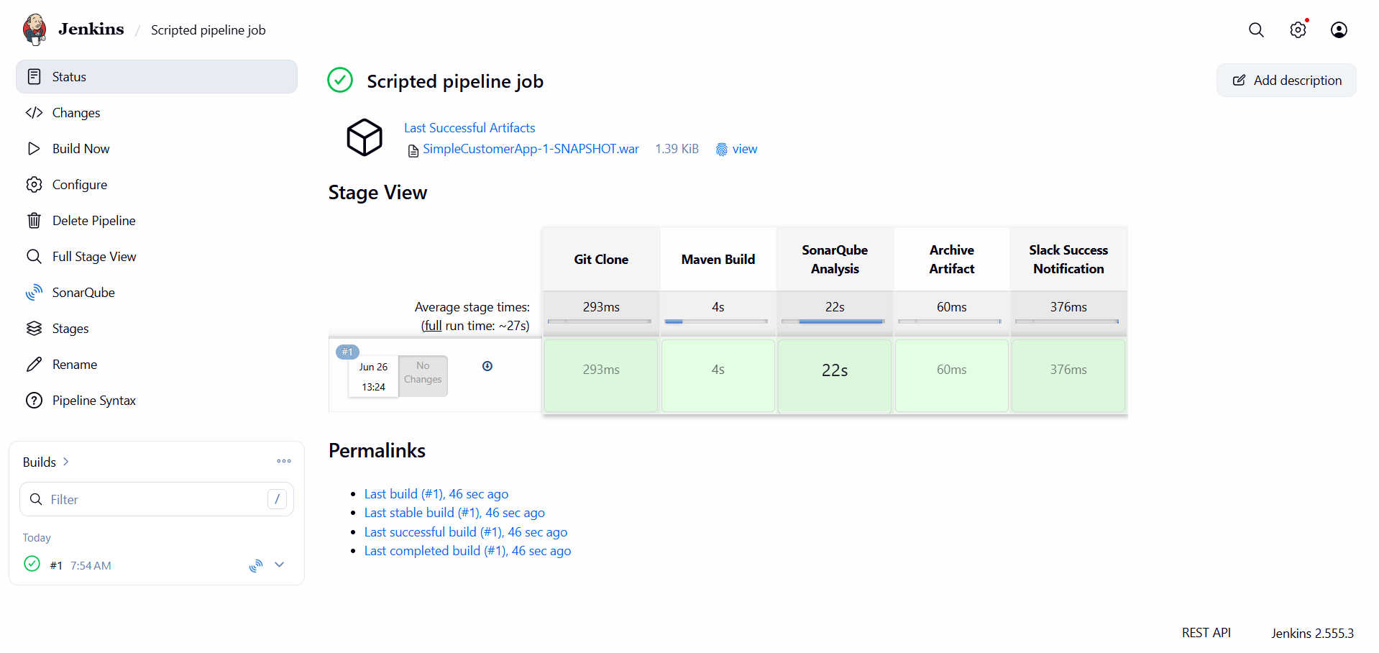

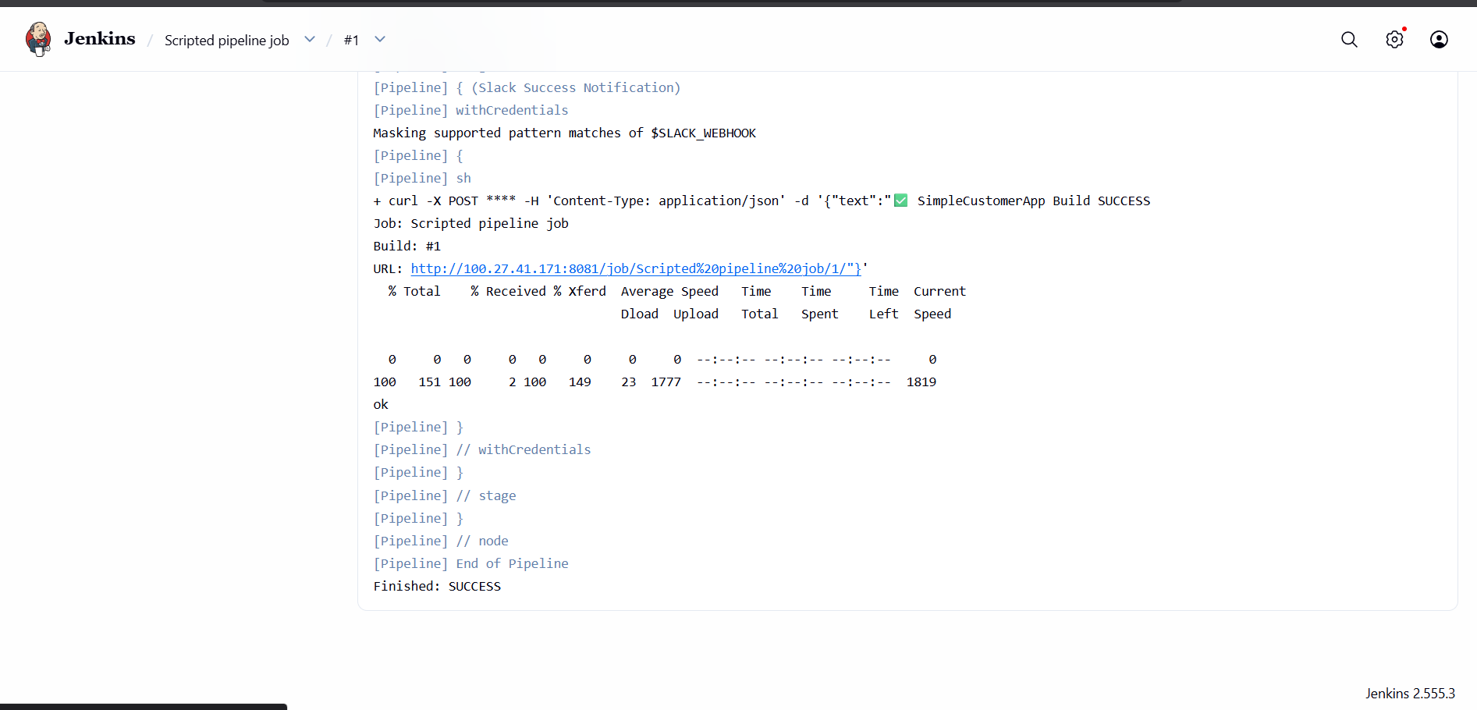
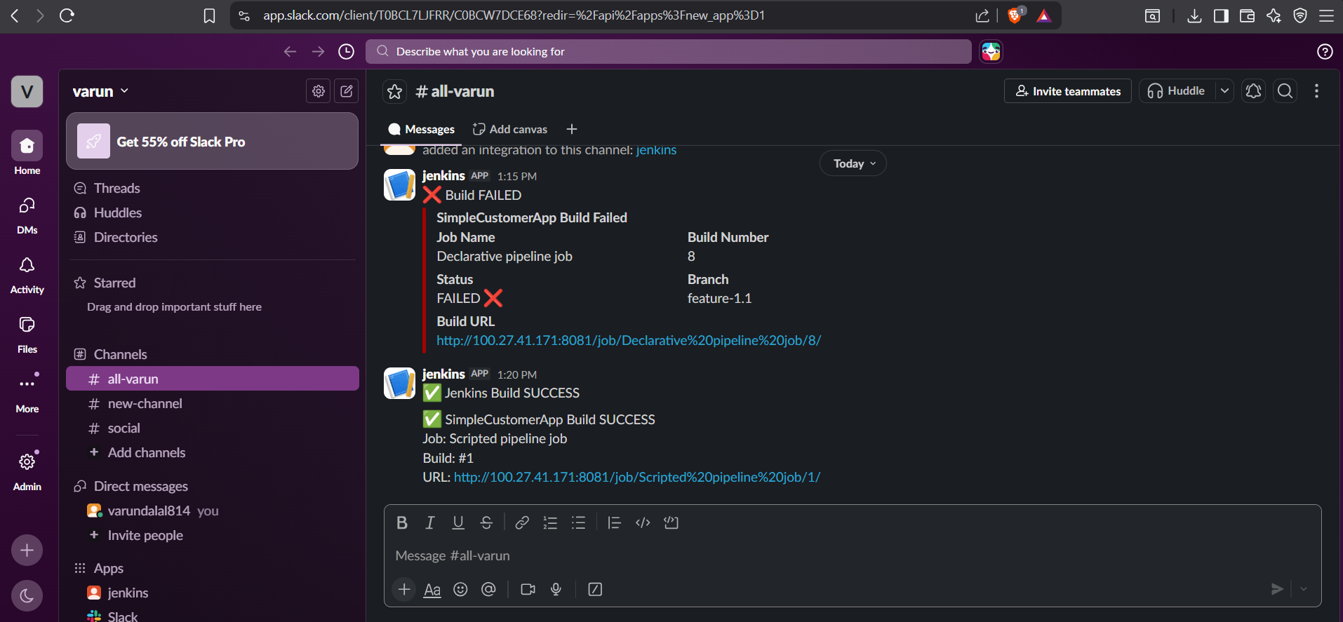

Steps to Create a Multi-Stage Pipeline Job in Jenkins
Step 1: Login to Jenkins
- Open Jenkins in your browser.
- Enter your username and password.

Step 2: Create a New Job
- Click New Item.
- Enter the job name:
  - Hiring-App-MultiStage
- Select Pipeline.
- Click OK.

Step 3: Configure the Job
- In the General section, add a description:
  - Multi-Stage Pipeline for Hiring App CI/CD.

Step 4: Configure the Pipeline
- Scroll down to the Pipeline section.
- Under Definition, select:
  - Pipeline script.

Step 5: Define the Pipeline Stages
The Multi-Stage Pipeline should execute the following stages sequentially:
- Checkout
  - Clone the source code from the GitHub repository.
- Compile
  - Compile the application source code.
- Test
  - Execute the test cases.
- Package
  - Package the application and generate the WAR file.
- SonarQube Analysis
  - Analyze the code quality using SonarQube.
- Archive Artifact
  - Archive the generated WAR file.

Step 6: Save the Job
- Click Save.

Step 7: Build the Job
- Click Build Now.

Step 8: Verify the Build
- Open the latest build from Build History.
- Check the Console Output to ensure all stages executed successfully.
- Verify that all stages completed without errors.

Expected Stage Flow
Checkout
↓
Compile
↓
Test
↓
Package
↓
SonarQube Analysis
↓
Archive Artifact
This completes the Create one Multi-Stage Pipeline Job requirement of your assignment.

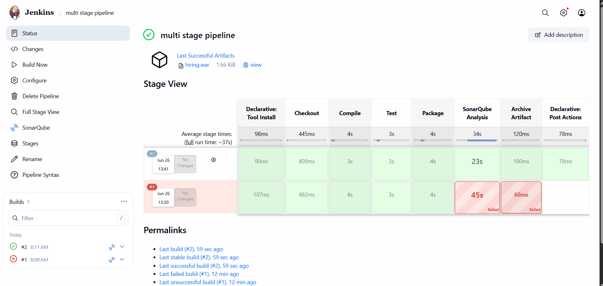
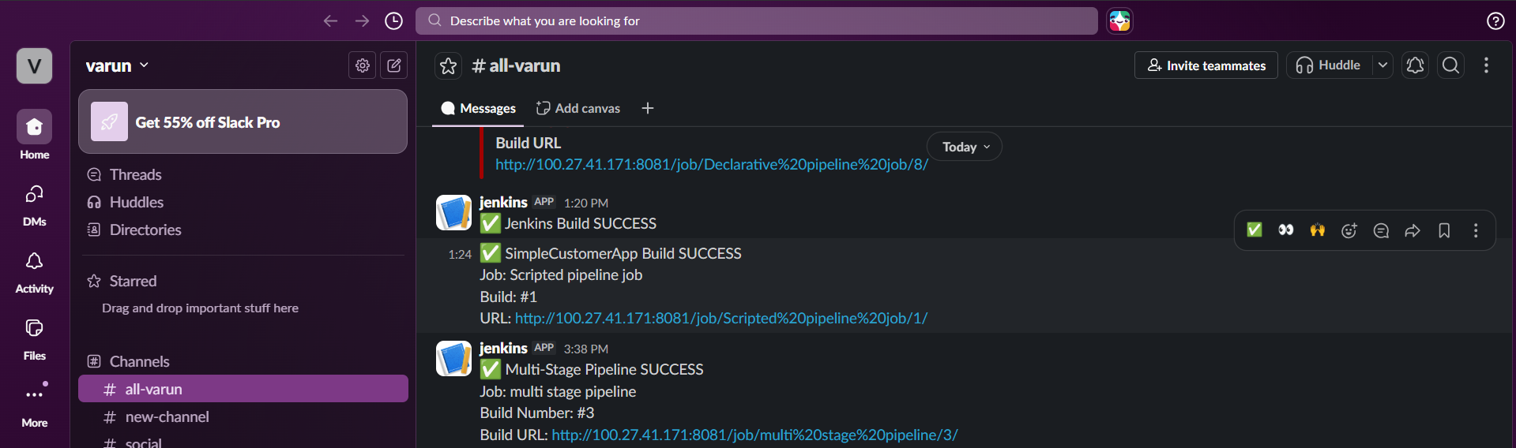
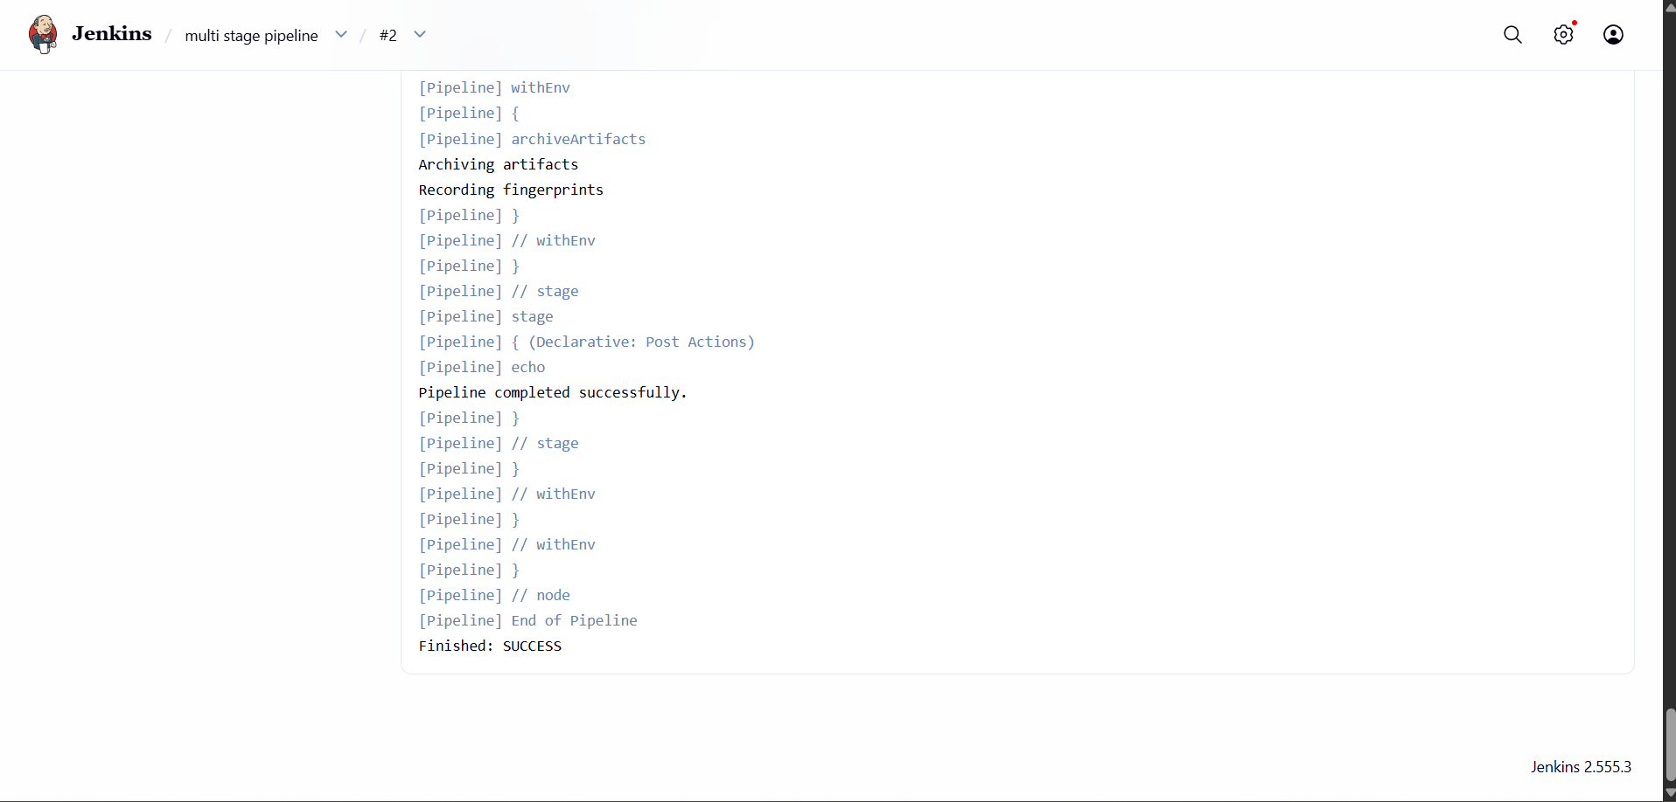

Steps to Create a Parallel Stage Pipeline Job in Jenkins
Step 1: Login to Jenkins
- Open Jenkins in your browser.
- Enter your username and password.

Step 2: Create a New Job
- Click New Item.
- Enter the job name:
  - Hiring-App-Parallel
- Select Pipeline.
- Click OK.

Step 3: Configure the Job
- In the General section, add a description:
  - Parallel Stage Pipeline for Hiring App CI/CD.

Step 4: Configure the Pipeline
- Scroll down to the Pipeline section.
- Under Definition, select:
  - Pipeline script.

Step 5: Define the Pipeline Stages
The Parallel Pipeline should execute the following stages:
- Checkout
  - Clone the source code from the GitHub repository.
- Parallel Build and Test
  - Run the following stages simultaneously:
    - Compile – Compile the application source code.
    - Unit Test – Execute the test cases.
- Package
  - Package the application and generate the WAR file.
- SonarQube Analysis
  - Analyze the code quality using SonarQube.
- Archive Artifact
  - Archive the generated WAR file.

Step 6: Save the Job
- Click Save.

Step 7: Build the Job
- Click Build Now.

Step 8: Verify the Build
- Open the latest build from Build History.
- Check the Console Output to ensure all stages executed successfully.
- Verify that the Compile and Unit Test stages ran in parallel.

Expected Stage Flow
Checkout
|
Parallel Build and Test
/ \
Compile Unit Test
|
Package
|
SonarQube Analysis
|
Archive Artifact
This completes the Create one Parallel Stage Pipeline Job requirement of your assignment.
